### **AI-powered Nutrition Analyzer for Fitness Enthusiasts**

Team Leader **:** B.Janani Bharathi

Team Member : R.Harini, V.Induja, D.Kirubadevi.

**Adding Dense Layers**

A dense layer is a deeply connected neural network layer. It is the most common and frequently used layer.

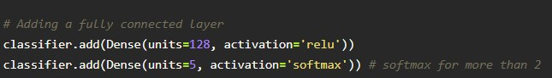

The number of neurons in the Dense layer is the same as the number of classes in the training set. The neurons in the last Dense layer, use soft max activation to convert their outputs into respective probabilities.

Understanding the model is a very important phase to properly using it for training and prediction purposes. Keras provides a simple method, a summary to get the full information about the model and its layers.

